Class

“The word love is proven by friends’’

(Shahzaib Yaqoob)
[ BSCS]

- Class
The keyword class is used to declare class and then write the class name or identifier. Member variable, Data member and Member function declare in class and its end with semicolon; .
Syntax

Cass Name
class identifier
{
Body of class;
} ;

- Member Variable / Member function / Data Member
Cass Name

class identifier
{
Private:
Member Variable / Data member

/
int a , b ;
float c ;
Member Function
public :
Function_Name ( )
Data member
{
Body of program ;
}
} ;
Data member
The variables which are declared in any class by using any fundamental data types (like int, char, float etc) or derived data type (like class, structure, pointer etc.) are known as Data Members
Member Function
Member functions are operators and functions that are declared as members of a class
Program Declaration inside the class function

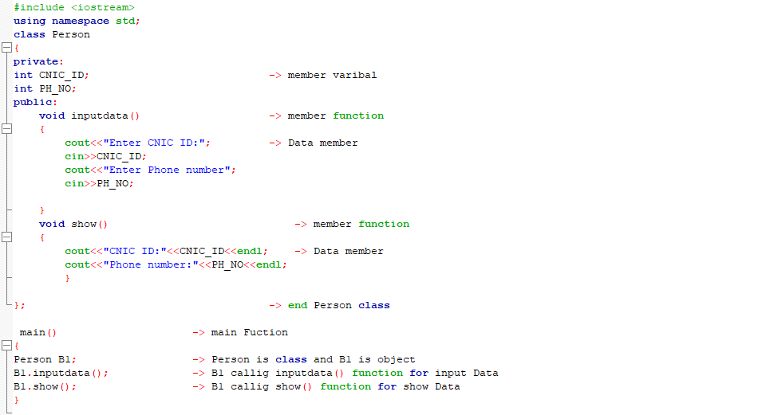
Member Function
Member Variable

Cass Name
Member Function

Data Member

Data Member

End of Class

Main Fuction

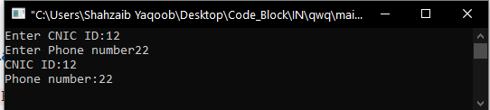

Program Declaration outside the class function
Syntax
Class Name

class identifier
{
Body of class
Public :
Member Function

Return_type function_name();
} ;
:: linked with Class

Class_name :: function_name()
{
Statements
}
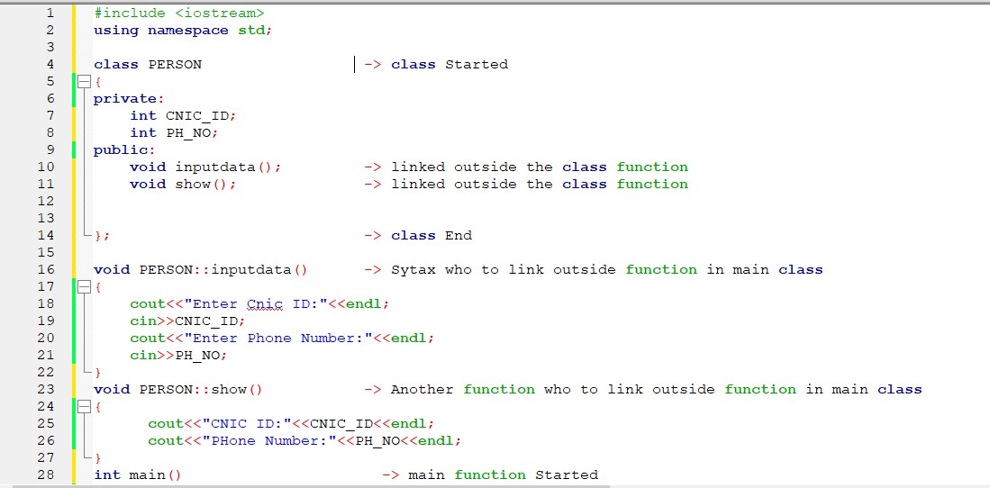

(Shahzaib Yaqoob)
[ BSCS]

